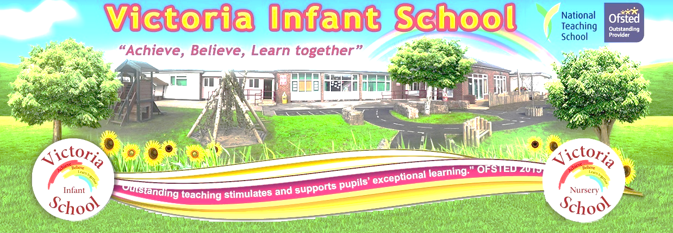
Newsletter Autumn Term 2019

11/10/18

Dear Parents and Carers,

.
Absence

It is parents/carers responsibility to report your child as absent, please contact the school before 8.50am and leave a message on the automated service using option 1, Failure to report absences will result in a phone call and a text from the school to explain the absence.

Halloween Disco

Our Halloween disco will take place on Wednesday 30th October from 4.00-5.30pm tickets cost £2 and are available to buy from the school office.

Holiday club half term

The school’s holiday club will be open Monday – Friday during school holidays. If you need affordable child care during this period then please feel free to book your child a place. Half day and full day care is available costing £20 for half a day and £25 for a full day.. Child care is also available for children who access our 2 year olds nursery however this MUST be booked in advanced so that staffing can be arranged prior to the care being needed. The cost for this care is £30 for half a day and £35 for a full day. Letters have been sent home with further details and booking arrangements.. Booking forms will be in your child’s book bags, If you require holiday club could you please return the form as soon as possible with payment.

2 Year Olds

This week the Rainbow nursery have been exploring the shaving foam in the tuff tray, we have been exploring the different colours and finding the different fish. The children enjoyed the sensory experience and were able to describe the texture of the foam. The children have been persevering to find their own pegs this week and have added a gold coin to our achievement rainbow.

3 Year Olds

This week the 3 year old nursery children have been focusing on the book ‘Goldilocks and the 3 bears. The children have been exploring the language of size and ordering aspects from the story. The children have also been collaborating to practice the songs and poems that we have performed for you today. We hope you enjoyed the performance,

Reception

This week reception has been continuing to learn about their topic “All about me”. They have looked at the different parts of their bodies and created a body made out of pasta shapes. They have been using their senses to listen, look, taste, hear and smell. The children have started practising their dance routine for the Carnegie performance and are very excited already. The children loved their music session with Happy Hannah this week where they looked at the story “The scarecrow”. They moved rhythmically like the cows in the field to the music and froze like statues when the scarecrow woke up.

Year 1

This week as mathematicians Year 1 has continued their learning about Addition within 10. They have been like Cathy the Capitalising Cat and been very resourceful using the resources around the classroom and continued to reason like Ronny the Reasoning Rhino to explain their answers.
The children have continued their learning about the Christian celebration of baptisms and been labelling their own diagram, taking into account the new vocabulary they have learnt to practise their writing with.
As scientist the children have designed a coat for the Jolly Postman to keep him warm on his cycle route to visit the other fairy tale characters. We have been trying to make sure that we understand the properties of the different materials so that we can choose the best coat for him.
As writers the children have created a fact file of their favourite character from The Jolly Postman. They have created some amazing descriptions along with some lovely pictures.
Finally, as geographers the children have had fun applying their learning about maps to create their journey to their own fairy tale land. They have thoroughly enjoyed these exciting activities this week!

Year 2 class 5

We have had another busy week in year 2. We have recapped our power of reading book 'Where the Wild Things Are' and created our very own storyboards! We used amazing sentence openers to start our sentences. We have been joined this week by Mr Hodgson (the Maths leader from Victoria Junior School) who has worked alongside us in Maths. We have also had a wonderful Kinder Cricket session which we thoroughly enjoyed. We are looking forward to our last week before half term.

Year 2 class 6

Year 2 have had another enjoyable week continuing our learning all about where the Wild Things Are. As young writers we have created our own storyboard, we have persevered this week to use a range of sentence openers and common exception words in our sentences. As mathematicians we have been deepening our knowledge of subtraction by using a variety of methods to subtract and using resources to help us. We have also used our reasoning skills to explain and justify our answers to our peers.
As scientists we have explored food chains, we watched a short clip and learnt about producers, consumers and predictors which gave us the knowledge so that we were able to create our own food chains and discuss the different habitats in which we could find them.
We were lucky to have Chris join us this week to teach us catching and throwing skills which will help us play Kinder Cricket. We have also enjoyed our usual P.E. and dance lessons in which we are working hard in.

Let’s Celebrate
Powerful Learner of the week
- Reception | - Class 1 | - Class 2 | - Class 3 | - Class 4 | - Class 5 | - Class 6
- Osacr  Scott | - Pacey  Khajeh | - Darcy  Biggans | - Maddox  Anderson | - Mia  Cuthbertson | - Scarlett  Park | - Heidi  Boyd

Outstanding Writer of the week
- Reception | - Class 1 | - Class 2 | - Class 3 | - Class 4 | - Class 5 | - Class 6
- Faith  Logan | - Sophie  Gill | - Anna  Gate | - Oliver  Bradshaw | - Jennifer  Jackson-Lamb | - Tyler  Whineray | - Brianna  Corrie

Mathlete of the Week
- Recpetion | - Class 1 | - Class 2 | - Class 3 | - Class 4 | - Class 5 | - Class 6
- Conley-Joe  Blaney | - Corey  Halbert | - Harvey  Fothergill | - Fatma  Cevher | - Chloe  Thompson | - Kylah-Jayne  Storey | - Joshua  Robinson

Nursery Learner of the week

Piglet AM | Piglet PM | Eeyore’s | Tigger AM | Tigger PM | - Winnies
- Conley-Joe  Blaney | - Caleb  Bell | - Mason  Wright | - Oliver  Perritt | - Elycia  Kerr | - Lily  Cowling

Nursery Writer of the week

Piglet AM | Piglet PM | Eeyore’s | Tigger AM | Tigger PM | - Winnies
- Amelia  Armstrong | - Hazal  Tutan | - Mila  Gallacher | - Joey  Adams | - Joey  Adams | - Ezra  Bell

Attendance Matters
Whole School Attendance for last week 07th- 11^{h} October 2019
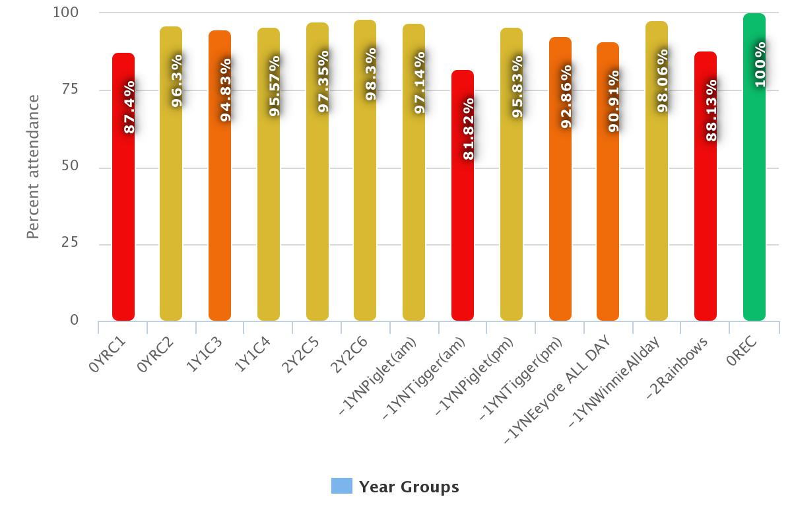
Whole School Attendance 3rd September-11th October 2019
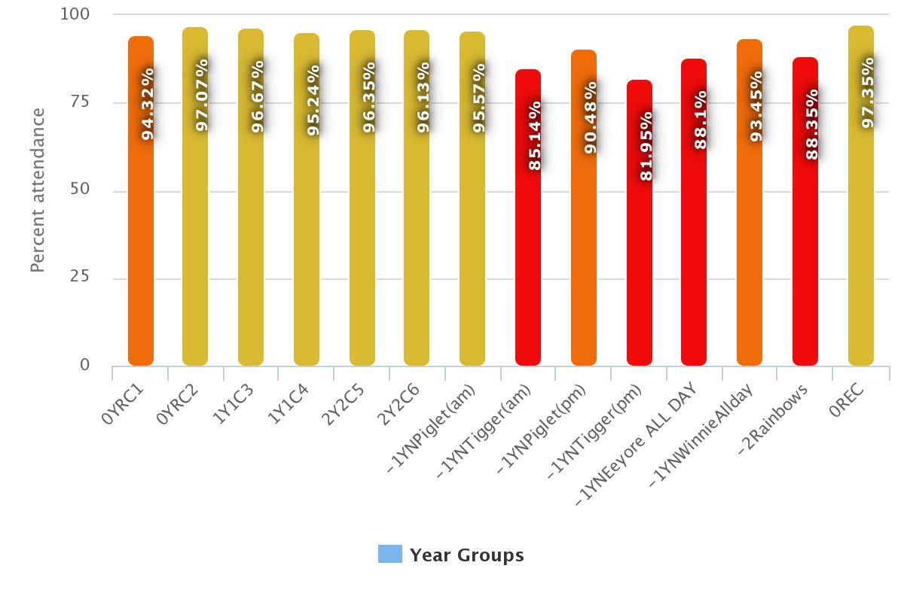

Diary Dates
Monday 14th October | Assessment Week. Children will take part in assessments to assess their knowledge, skills and understanding of the curriculum.
Tuesday 15th October | World food day  Children will taste food from around the world
Wednesday 16th October | Kinder cricket 9-11 year one/two
Thursday 17th October | PSCO talking to the children about bonfire safety 10am
Friday 19th October until Monday 28th October | Break up for half term
Wednesday 30th October | Halloween Disco | Reception, Year 1 and Year 2
Monday 4th November | Phonics breakfast week  Parents are invited into school to have breakfast and join in with phonics.
Tuesday 5th November | Bonfire night 5pm food/refreshments 6pm bonfire.  Community bonfire to be held at Victoria Junior School
Friday 8th November | Remembrance assembly 10am for pupil
Sunday 10th November | Workington remembrance service.  Pupils can join staff to lay a wreath at Vulcans park cenotaph.
Monday 11th November | Parent’s meetings week.  Details to follow  Please bring your child to the meeting
Monday 11th November | Anti-bulling week  Safety week including; Road safety, water safety, fire safety online and social media safety.
Thursday 14th November | Doodle bug programme for KS1  Growth mind set training for children. Parent’s workshop for year2 parents and children. Details to follow
Friday 15th November | Children in need.  Children can come to school dressed in yellow, PJ’s or children in need themed.
Monday 18th November | Road safety week.  Activities planned to support children’s understanding of how to keep safe near roads.
Friday 22nd November | Christmas Carnegie dress rehearsal, All costumes must have been sorted and tried on the children for size before today.
Monday 25th November | Christmas decoration go up in school
Wednesday 27th November | Christmas performance at the Carnegie
Friday 28th November | Decorate the Christmas tree
Monday 2nd December | Children will have photo taken with Santa.
5th December | Santa Express
Monday 10th December | 3 year old nursery and reception nativity in the school hall  9.15am and 2.00pm | Nursery and Reception
Wednesday 11th December | Christmas Dinner day for all pupils.  Children can wear Christmas jumpers with uniforms.
Thursday 12th December | Nursery Nativity  2 year old and 3 year old nursery.  9.15 and 2.00pm in the school hall | 2 and 3 year old nursery
Thursday 12th December | Year one and two trip to Carlisle to watch the pantomime. | Key stage one and two pupils
Friday 13th December | National Christmas jumper day.
Wednesday 18th December | Carol service  St Michaels church  Reception, Year 1 & Year 2  Service starts at 1,15pm  Victoria juniors starts at 2.30pm | Reception, year one and two
Thursday 19th December | School closes at 12.45 there will be no afterschool care or holiday club Christmas holidays are 19th December until 6th January
Monday 6th January | Return to school.  8.50am start  Breakfast club 7.50am

Please note for the most up to date list of activities and events please visit the school website, www.victoriaschool.org.uk or contact admin@victoria-inf-workington.cumbria.sch.uk

